Family Fun & Community Safety Day

On Saturday, the 15th of July the Grange Farm Resident Steering Group united the community once again with their Family Fun and Community Safety Day. The Steering Group planned and hosted the event for the second year in South Harrow, which was another huge success for the group with around 250 people attending the event.

The Family Fun and Community Safety Day had activities for the kids in the community including trampolines, face painting, and a bouncy castle just to name a few. This was all possible with the help of the community groups and organisations; The Light House Café, Hope, Ignite, Kidology, Kingdom Security and Watford Football Club.

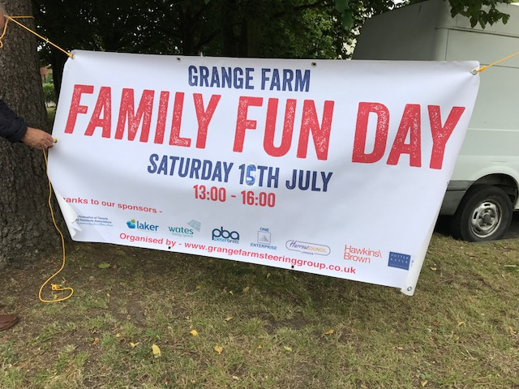

The event also included live music, with help from Harrow Radio and three live bands. Residents joined in by dancing and enjoying the atmosphere provided by the steering group, with many expressing excitement for the event next year.

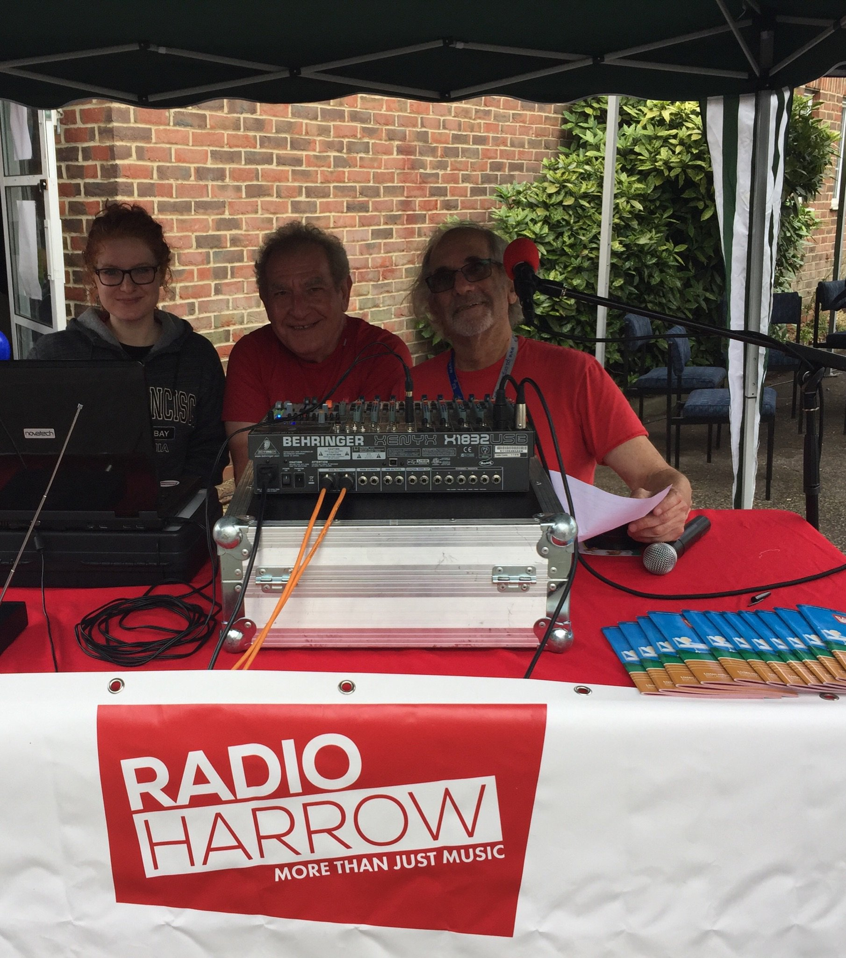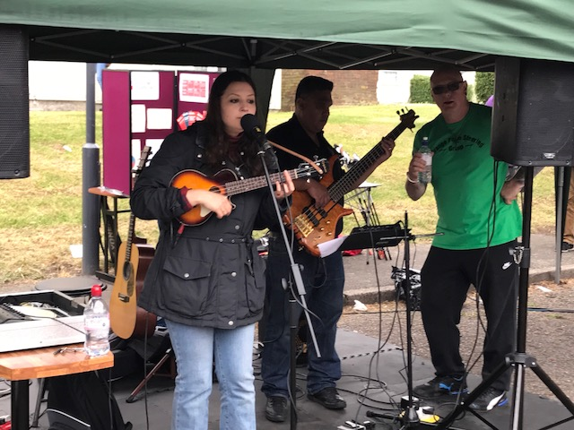

To add to the excitement of the day the residents were joined by Mayor of Harrow Margaret Davine and the Leader of Harrow Council (Councillor Sachin Shah). The Mayor gave a short speech at the event stating, “This is an extremely good community event: it has lots of people enjoying themselves and children having fun. It shows Harrow at its very best; when people from many different backgrounds and cultures come together and enjoy each other’s company.”
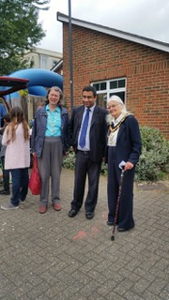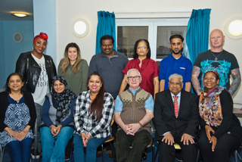

The Vice Chair of the Steering Group, Bill Beardon, said “this event is organised to bring the community together and make sure everyone is included.” Which is exactly what happened, the community came together to enjoy the festivities.

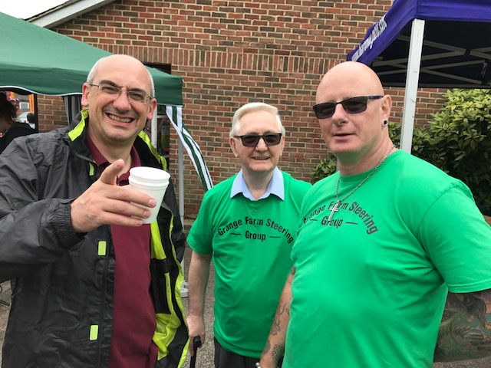

The Steering group was joined local police officers, Xcite and Housing Services and Hawkins Brown architects to create a fun day for one and all. Community Safety is a big thing for the Steering Group so being joined by the police force and community groups, such as Victim Support, shows residents that they are listening to concerns and value what they are saying.

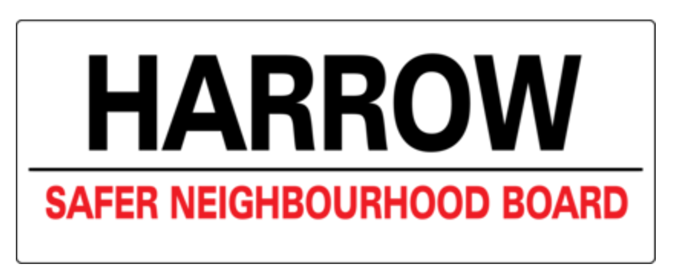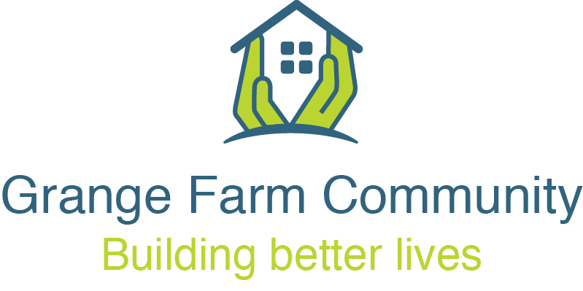

This fabulous day was made possible by the Steering Group with the added help from Young Harrow Foundation who provided additional funding to help support the community safety initiative. This was a successful event for both the Steering Group and the residents filled with fun and the joy of a united community.

END

For more details contact:
Raj from One Enterprise Ltd: raj@1enterprise.co.uk or 0845 057 3995

